1. Technology
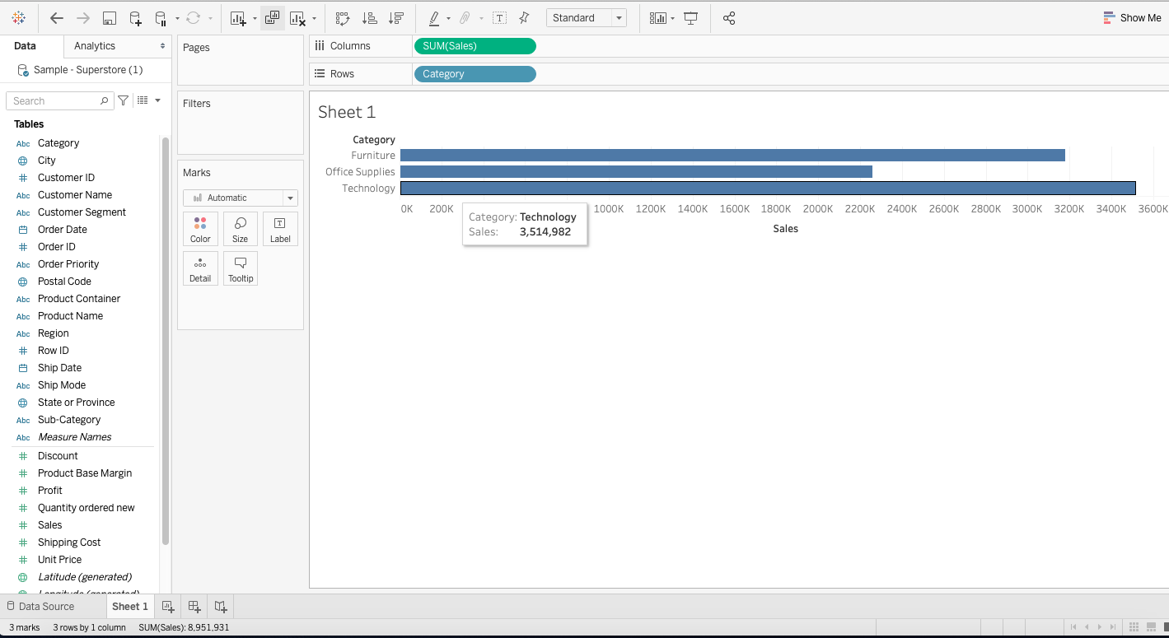

2. 253,600
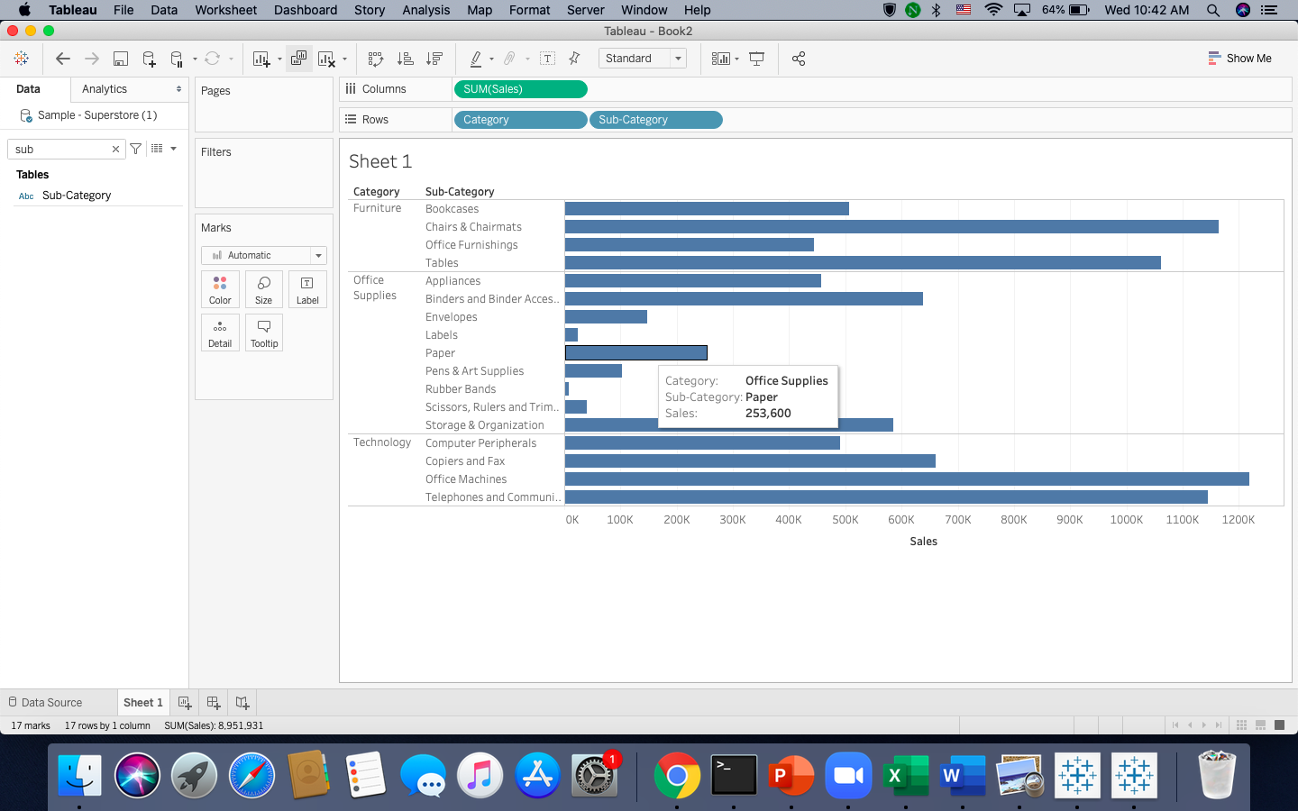

3. Office Machines
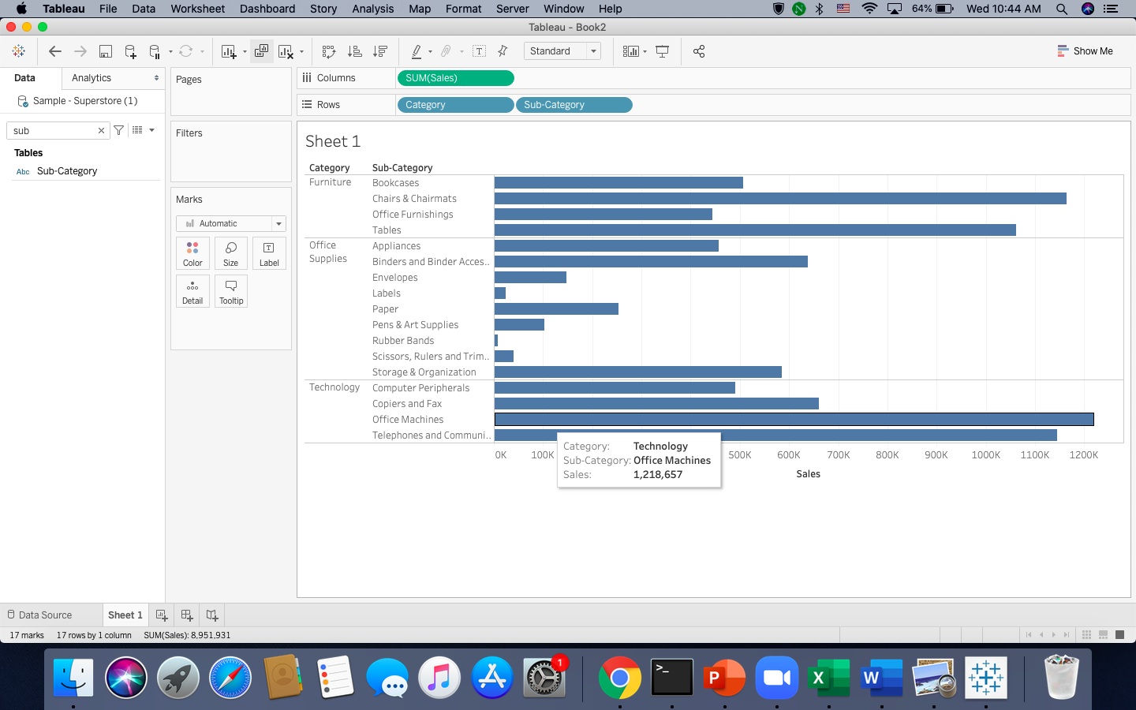

4. Rubber Bands
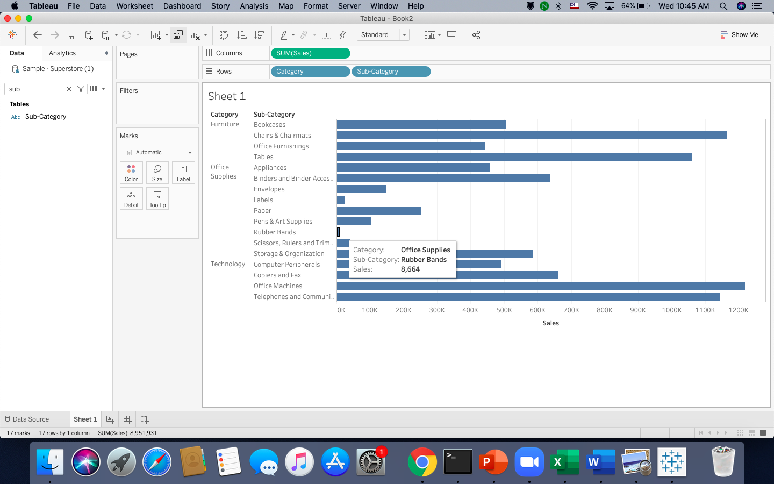

5.
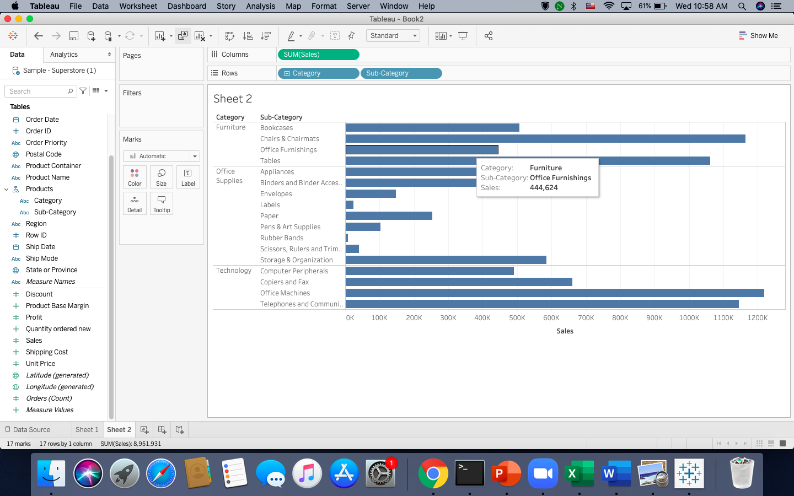

6. I think such infinite number is informative because in the sub-category which has the highest sale, we can find out a specific product that has the highest sale. From there, we can focus on producing that product.

7. Product name, category, sub-category.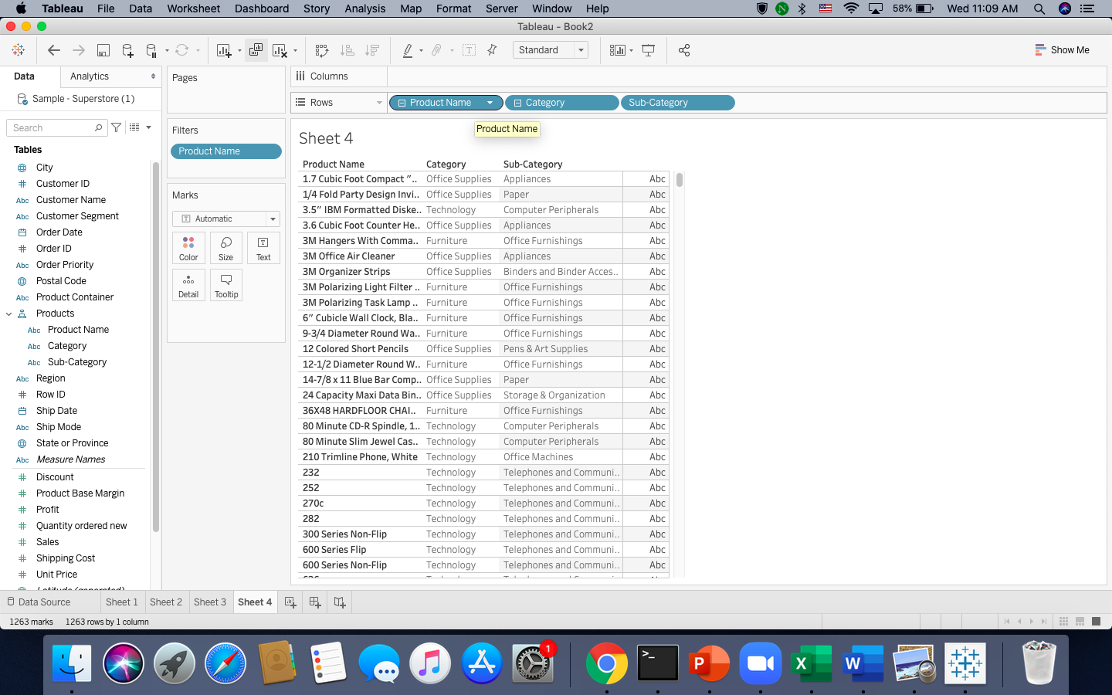

8. October 12 has the higher sales than April 12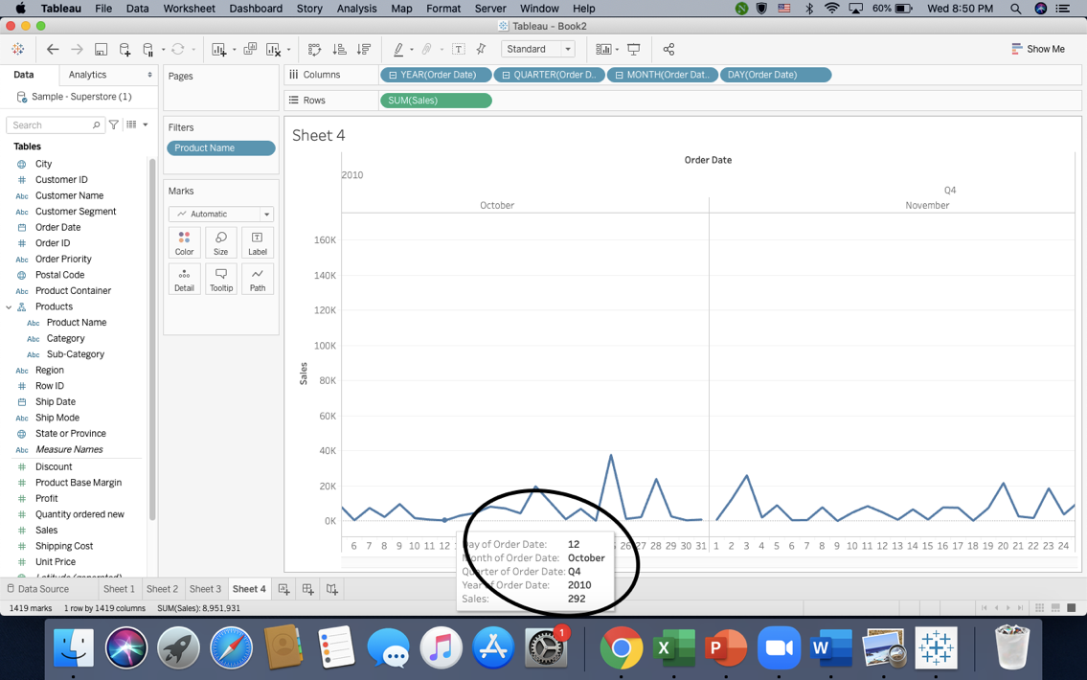
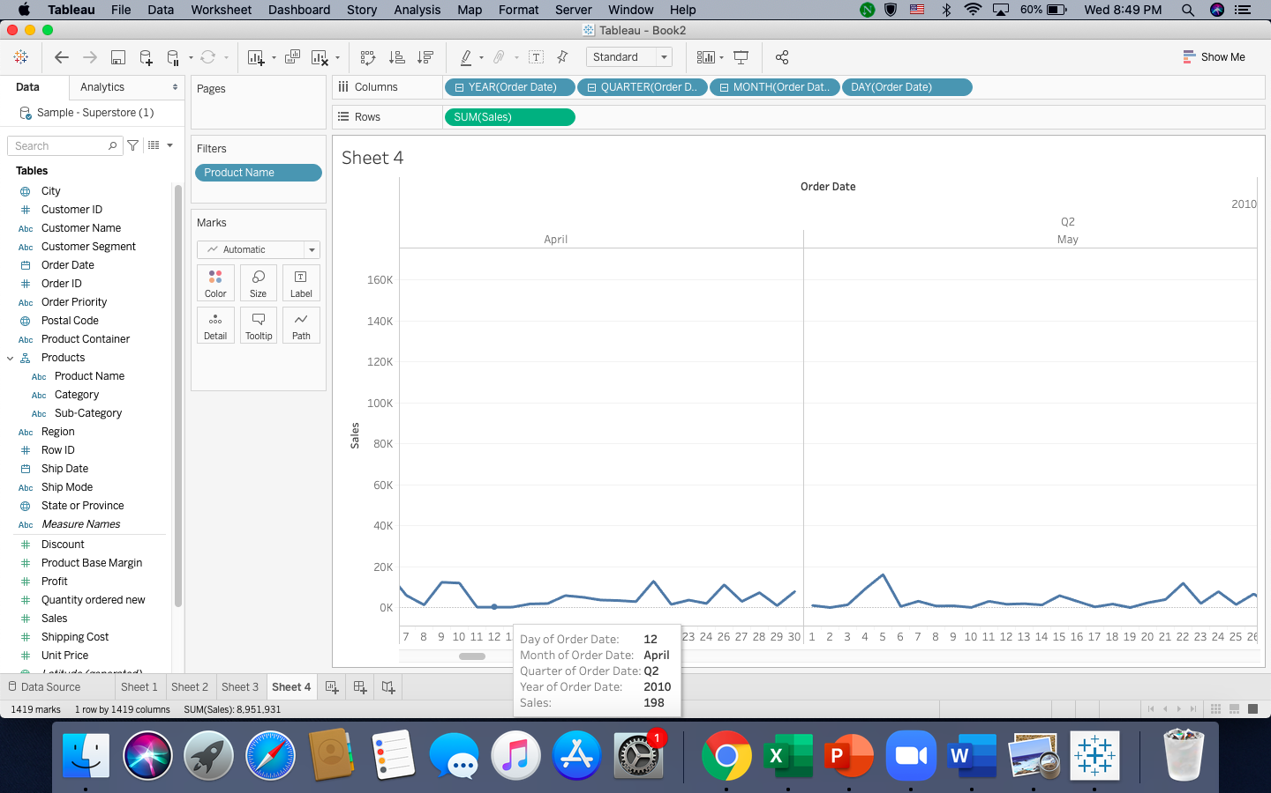

9. November 2012 has the highest sale. 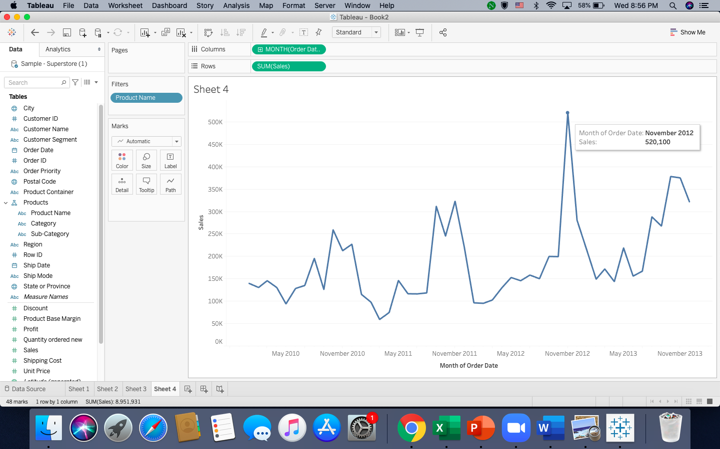

10. March 2011 has the lowest sale
